Self-Intersecting Path

Definition
# Source: AI Source: Provided by: [Data Path: Persons Table -> ID Column: 1, Name_En Column: Motasem Essam] -> From: [ChatGPT] on [7/25/2026]
A Self-Intersecting Path is a geometric path that intersects itself at one or more points during its traversal.
For a parameterized path
$$r:\left[a , b\right]→R^{n}$$
a self-intersection occurs when two distinct parameter values correspond to the same point:
$$\boxed{r\left(t_{1}\right)=r\left(t_{2}\right) \text{for} t_{1}≠t_{2}}$$
where the repeated point is not merely the allowed coincidence of the initial and final points of a simple closed path.
Simple Definition
A Self-Intersecting Path is a path that crosses or meets itself at one or more points.

Main Classification
# Source: AI Source: Provided by: [Data Path: Persons Table -> ID Column: 1, Name_En Column: Motasem Essam] -> From: [ChatGPT] on [7/25/2026]
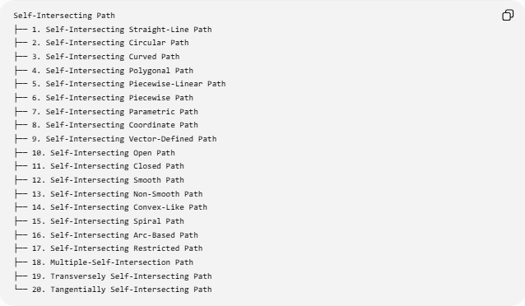
Self-Intersecting Path
├── 1. Self-Intersecting Straight-Line Path
├── 2. Self-Intersecting Circular Path
├── 3. Self-Intersecting Curved Path
├── 4. Self-Intersecting Polygonal Path
├── 5. Self-Intersecting Piecewise-Linear Path
├── 6. Self-Intersecting Piecewise Path
├── 7. Self-Intersecting Parametric Path
├── 8. Self-Intersecting Coordinate Path
├── 9. Self-Intersecting Vector-Defined Path
├── 10. Self-Intersecting Open Path
├── 11. Self-Intersecting Closed Path
├── 12. Self-Intersecting Smooth Path
├── 13. Self-Intersecting Non-Smooth Path
├── 14. Self-Intersecting Convex-Like Path
├── 15. Self-Intersecting Spiral Path
├── 16. Self-Intersecting Arc-Based Path
├── 17. Self-Intersecting Restricted Path
├── 18. Multiple-Self-Intersection Path
├── 19. Transversely Self-Intersecting Path
└── 20. Tangentially Self-Intersecting Path

1. Self-Intersecting Straight-Line Path
# Source: AI Source: Provided by: [Data Path: Persons Table -> ID Column: 1, Name_En Column: Motasem Essam] -> From: [ChatGPT] on [7/25/2026]
A Self-Intersecting Straight-Line Path requires multiple straight-line pieces that cross one another.
A single straight segment cannot self-intersect, so this type refers to a path containing multiple straight pieces.
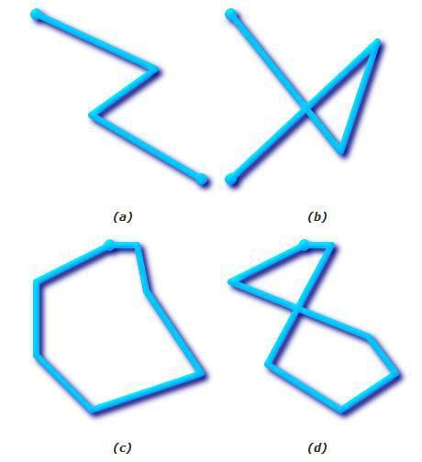
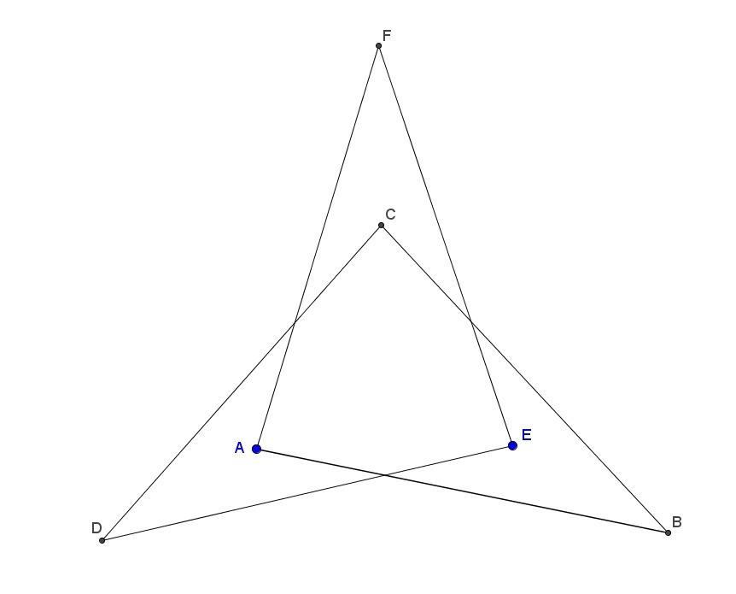
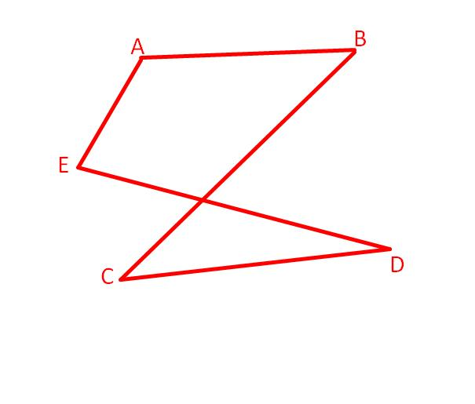
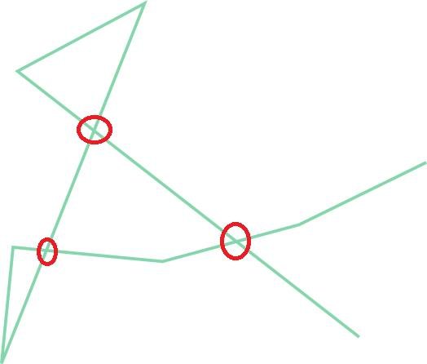
Example
Consider:
$$A→B→C→D$$
where nonconsecutive segments such as $AB$and $CD$cross.
Then the path is self-intersecting.

2. Self-Intersecting Circular Path
# Source: AI Source: Provided by: [Data Path: Persons Table -> ID Column: 1, Name_En Column: Motasem Essam] -> From: [ChatGPT] on [7/25/2026]
A single traversal of an ordinary circle is not self-intersecting.
Therefore, a Self-Intersecting Circular Path requires a path constructed from circular portions or a repeated/multiple-loop traversal that produces an intersection.
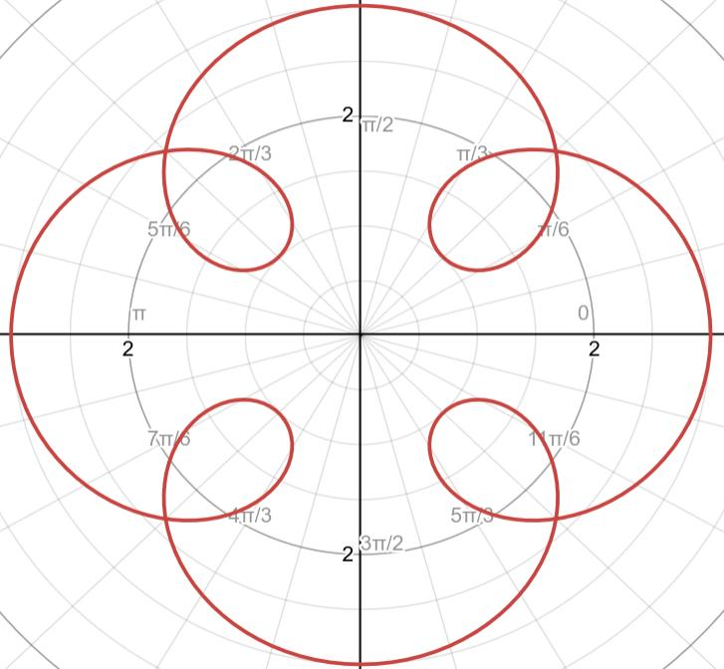
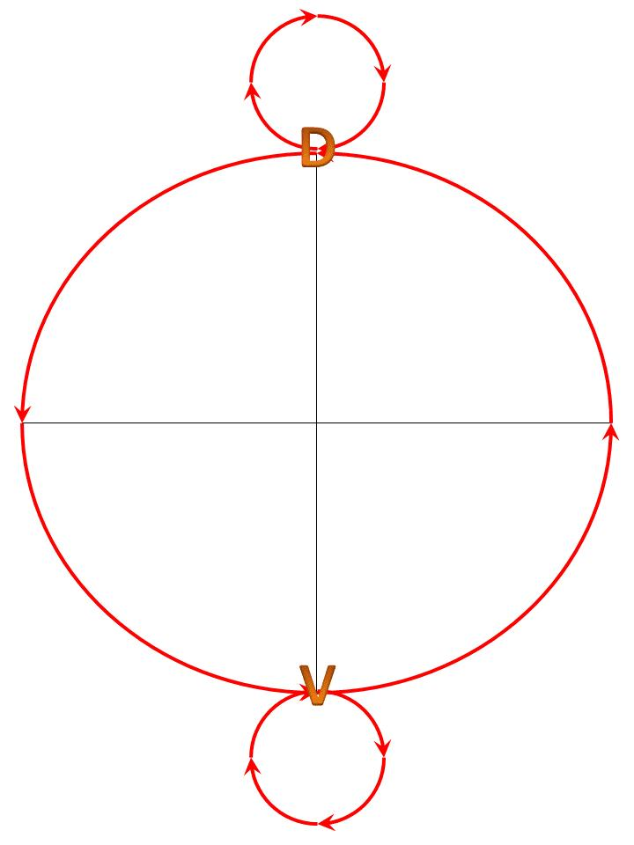
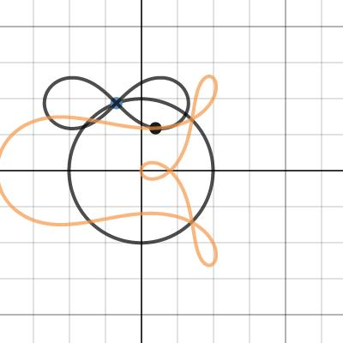
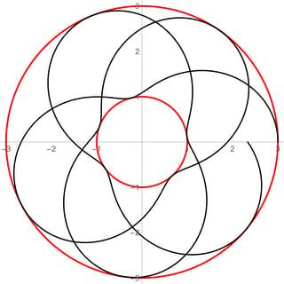
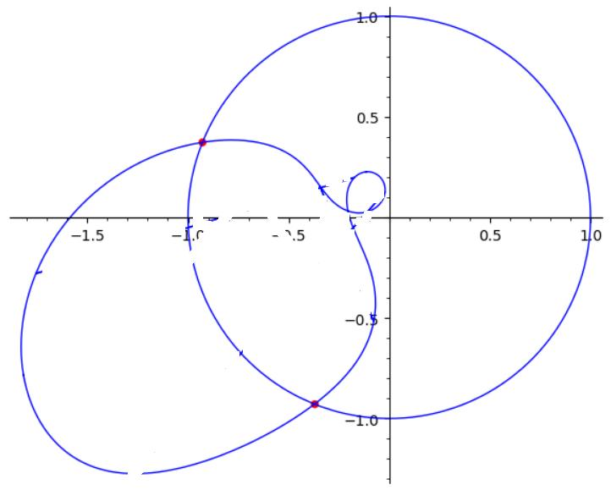
Example
Two circular arcs can cross at a point:
$${\text{Circular Arc}}_{1}∩{\text{Circular Arc}}_{2}=\left\{P\right\}$$
The combined path is self-intersecting.

3. Self-Intersecting Curved Path
# Source: AI Source: Provided by: [Data Path: Persons Table -> ID Column: 1, Name_En Column: Motasem Essam] -> From: [ChatGPT] on [7/25/2026]
A Self-Intersecting Curved Path is a curved path that crosses itself.
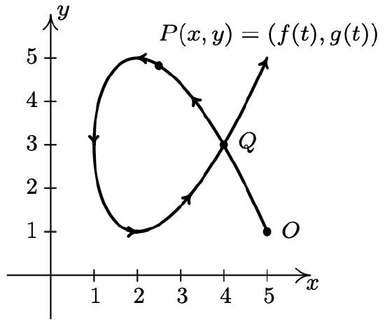
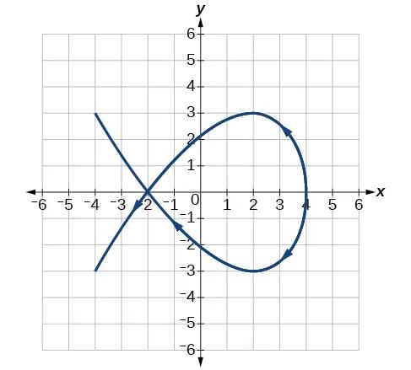
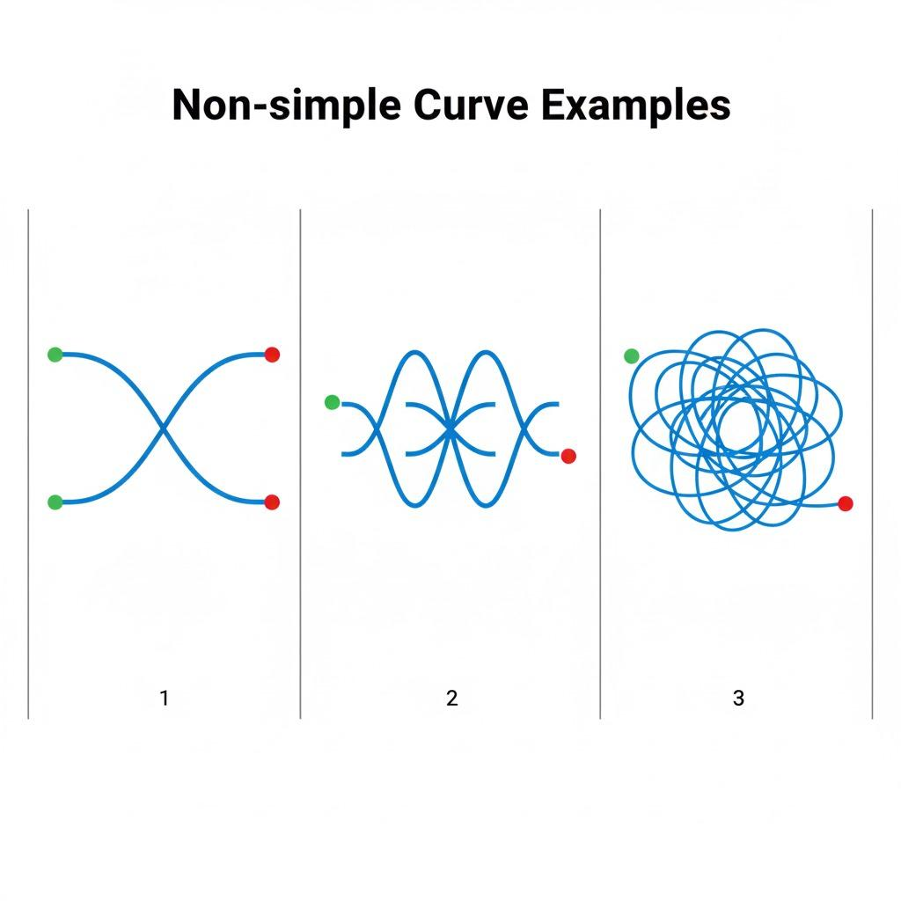
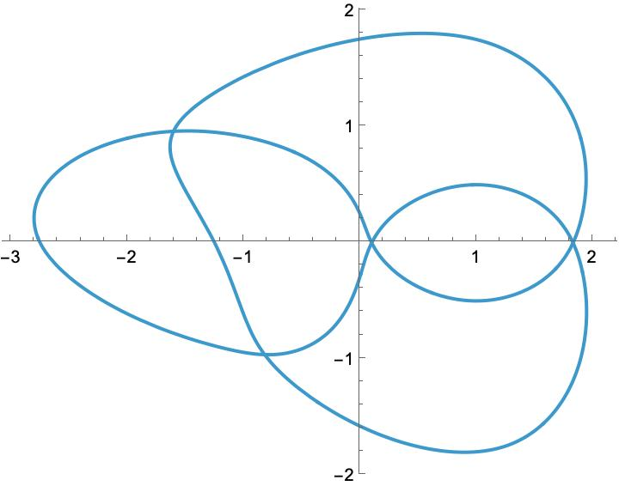
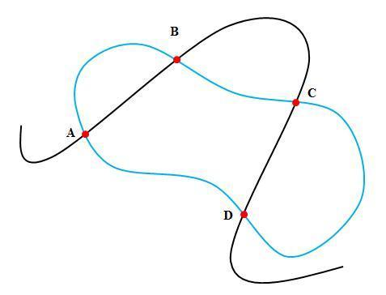
Example
A figure-eight-shaped curve is a classic example.
At the crossing point $P$:
$$\boxed{r\left(t_{1}\right)=r\left(t_{2}\right), t_{1}≠t_{2}}$$

4. Self-Intersecting Polygonal Path
# Source: AI Source: Provided by: [Data Path: Persons Table -> ID Column: 1, Name_En Column: Motasem Essam] -> From: [ChatGPT] on [7/25/2026]
A Self-Intersecting Polygonal Path consists of connected straight-line segments where at least two nonconsecutive segments intersect.
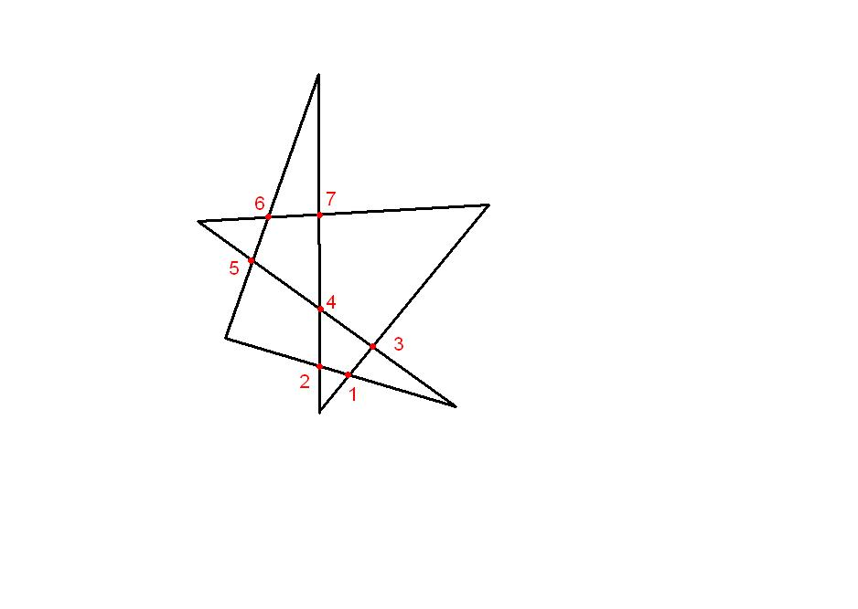
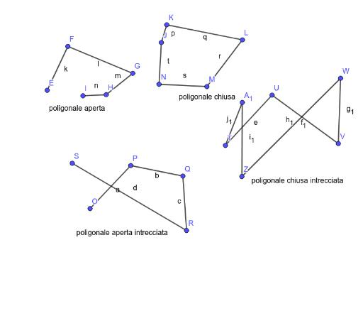
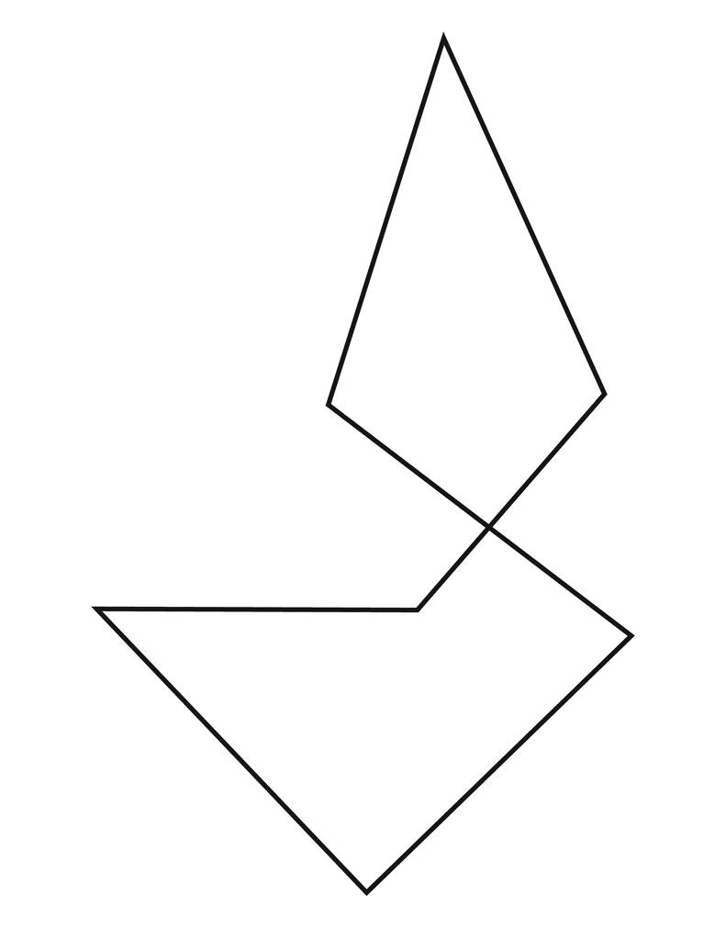
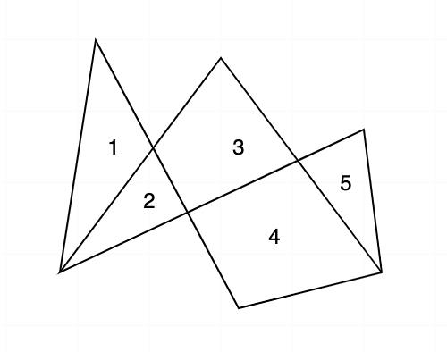
Example
$$A→B→C→D→E$$
If:
$$\overset{‾}{AB}∩\overset{‾}{CD}≠∅$$
then the polygonal path is self-intersecting.

5. Self-Intersecting Piecewise-Linear Path
# Source: AI Source: Provided by: [Data Path: Persons Table -> ID Column: 1, Name_En Column: Motasem Essam] -> From: [ChatGPT] on [7/25/2026]
A Self-Intersecting Piecewise-Linear Path consists entirely of straight-line pieces and contains one or more self-intersections.
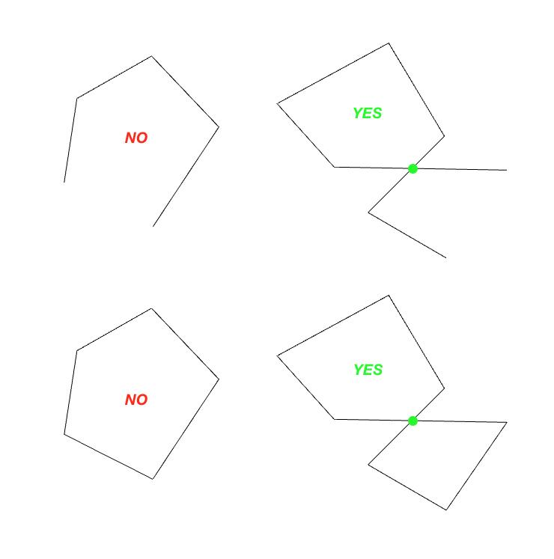
This is essentially a self-intersecting polygonal path.
$$\boxed{\text{Self-Intersecting Piecewise-Linear Path}≈\text{Self-Intersecting Polygonal Path}}$$

6. Self-Intersecting Piecewise Path
# Source: AI Source: Provided by: [Data Path: Persons Table -> ID Column: 1, Name_En Column: Motasem Essam] -> From: [ChatGPT] on [7/25/2026]
A Self-Intersecting Piecewise Path contains several connected geometric pieces, with at least two pieces intersecting at a point other than their intended consecutive connection.
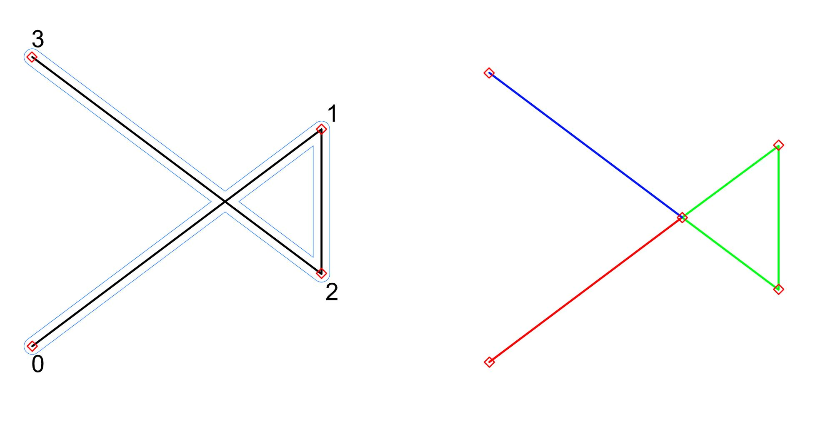
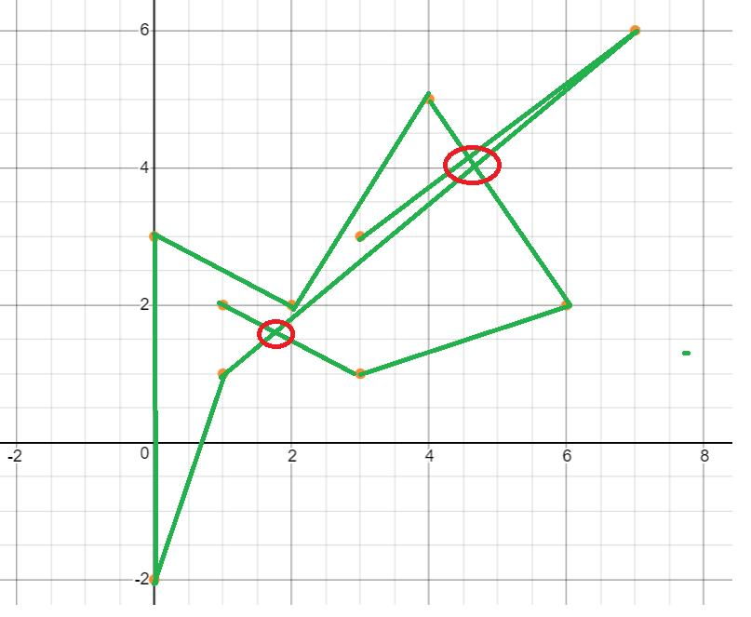
Example
$$\text{Straight}→\text{Circular Arc}→\text{Straight}$$
where the final straight segment crosses the first segment.

7. Self-Intersecting Parametric Path
# Source: AI Source: Provided by: [Data Path: Persons Table -> ID Column: 1, Name_En Column: Motasem Essam] -> From: [ChatGPT] on [7/25/2026]
A Self-Intersecting Parametric Path is described using a parameter and contains at least two distinct parameter values producing the same point.
$$\boxed{r\left(t_{1}\right)=r\left(t_{2}\right), t_{1}≠t_{2}}$$
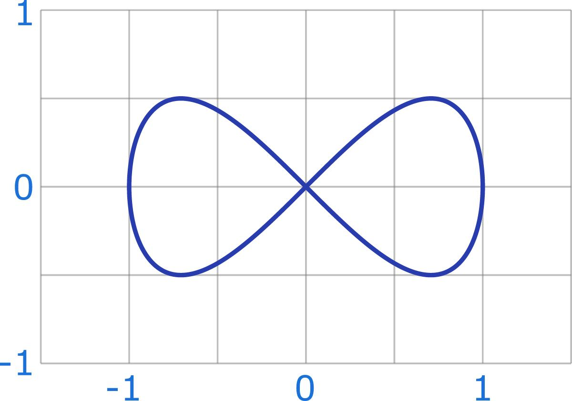
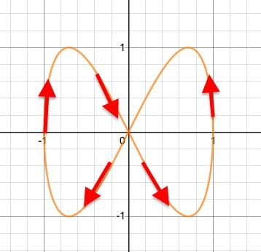
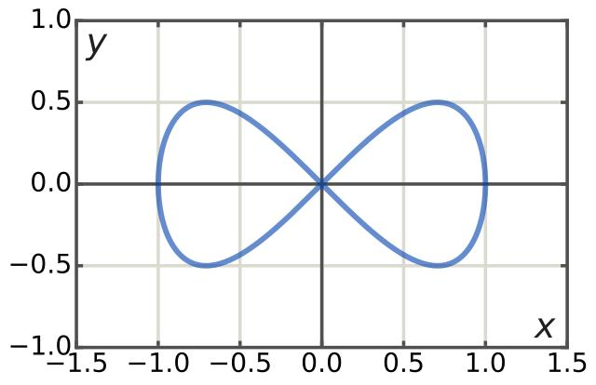
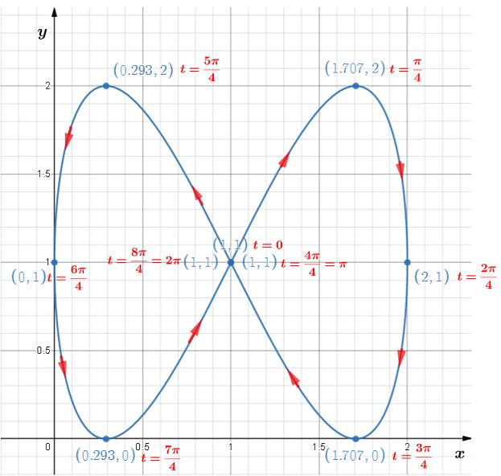
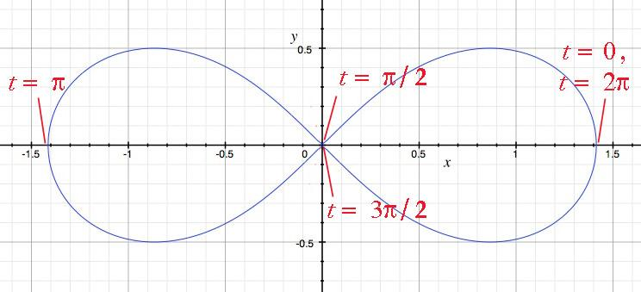
Example
Consider a figure-eight parameterization:
$$x=\sin{t} \\ y=\sin{2}t$$
At different parameter values, the curve can pass through the same point.

8. Self-Intersecting Coordinate Path
# Source: AI Source: Provided by: [Data Path: Persons Table -> ID Column: 1, Name_En Column: Motasem Essam] -> From: [ChatGPT] on [7/25/2026]
A Self-Intersecting Coordinate Path is described by coordinate equations and contains one or more self-intersections.
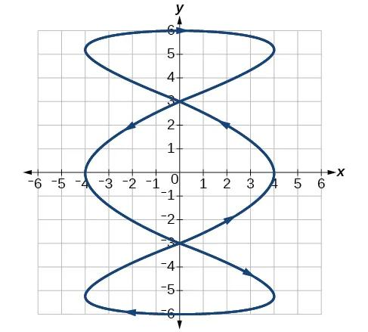
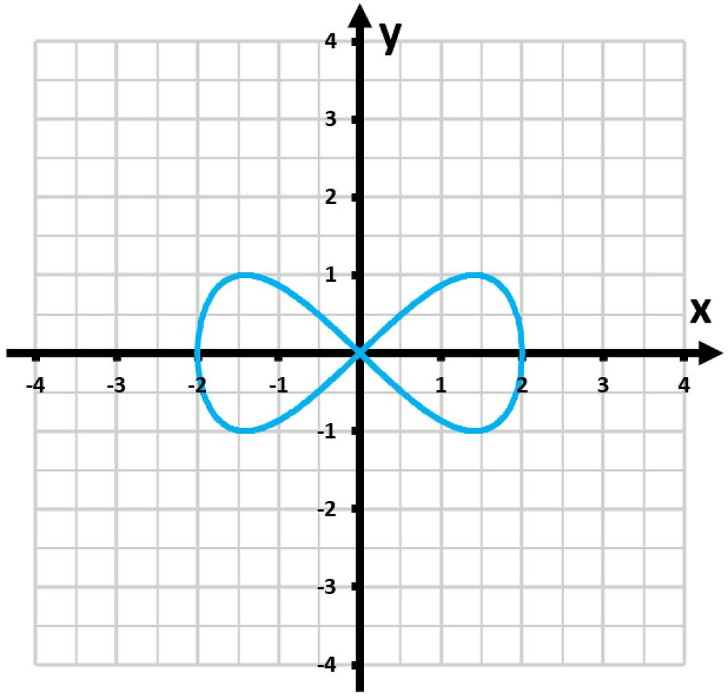
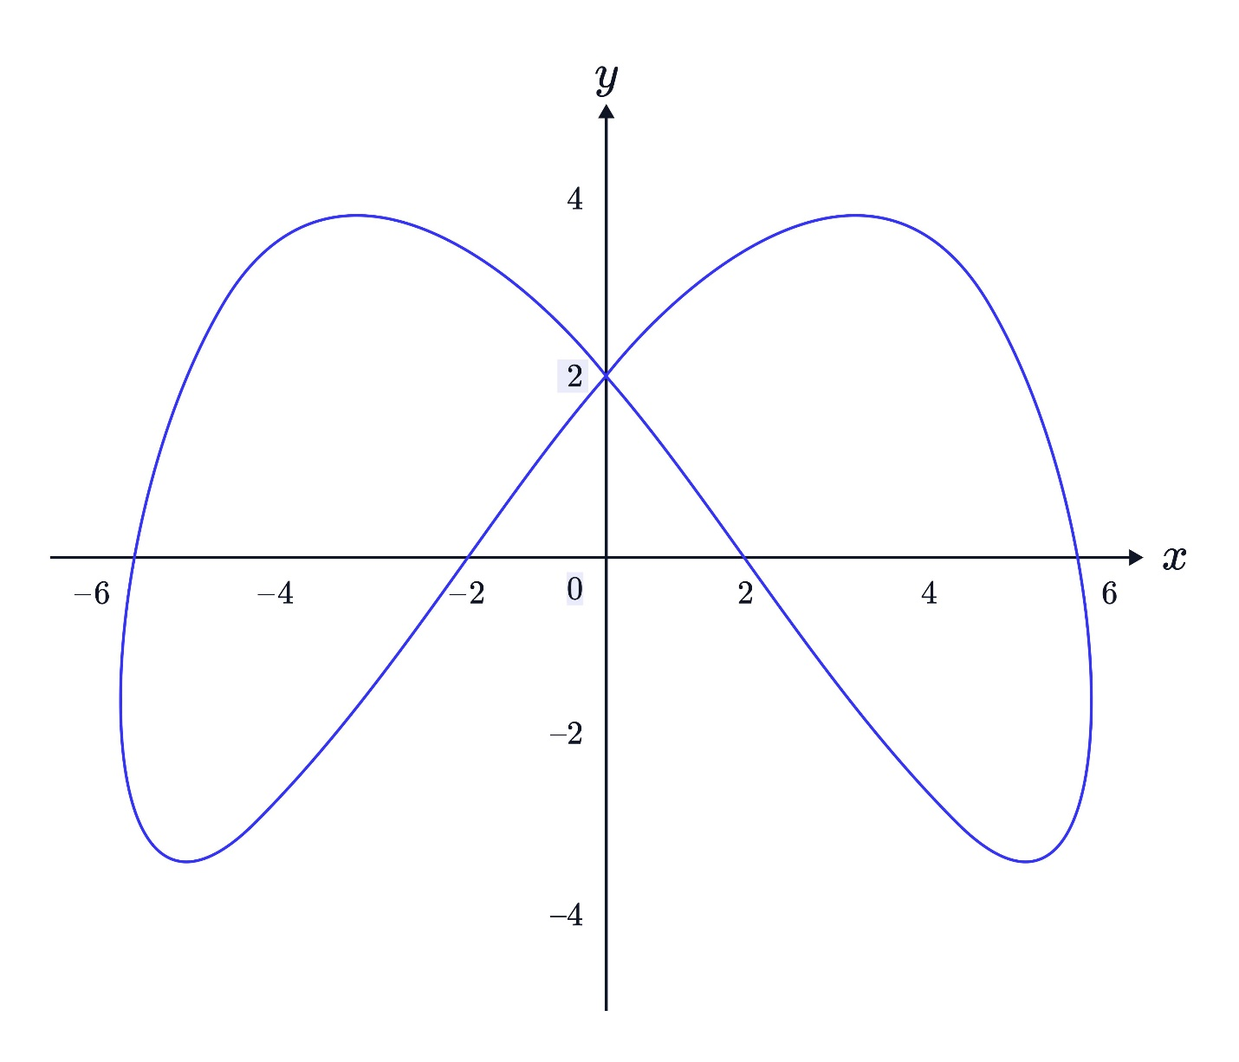
Example
A figure-eight curve can be represented by an equation or parametric coordinate system and has a crossing point.

9. Self-Intersecting Vector-Defined Path
# Source: AI Source: Provided by: [Data Path: Persons Table -> ID Column: 1, Name_En Column: Motasem Essam] -> From: [ChatGPT] on [7/25/2026]
A Self-Intersecting Vector-Defined Path uses a vector-valued function:
$$r\left(t\right)=\left\langle x , \left(t\right)y\left(t\right)\right\rangle$$
and satisfies:
$$r\left(t_{1}\right)=r\left(t_{2}\right)$$
for distinct $t_{1},t_{2}$.
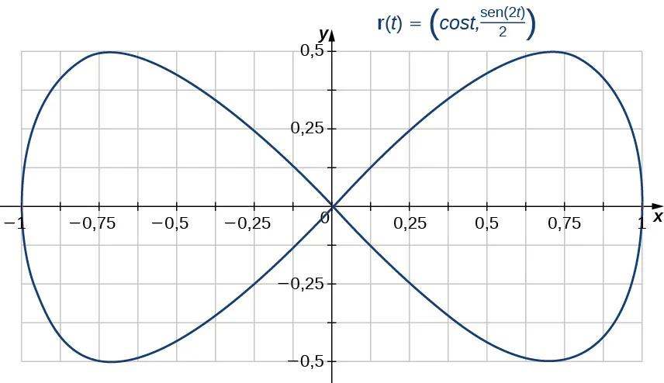
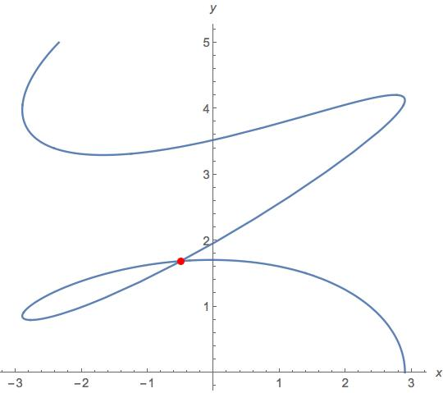

10. Self-Intersecting Open Path
# Source: AI Source: Provided by: [Data Path: Persons Table -> ID Column: 1, Name_En Column: Motasem Essam] -> From: [ChatGPT] on [7/25/2026]
A Self-Intersecting Open Path has different starting and ending points but crosses itself.
$$\boxed{P_{s}≠P_{e}}$$
and at least one additional repeated point exists.
Example
A path may start at $A$, cross itself at $P$, and finish at $B$:
$$A→⋯→P→⋯→P→⋯→B$$
with:
$$A≠B.$$

11. Self-Intersecting Closed Path
# Source: AI Source: Provided by: [Data Path: Persons Table -> ID Column: 1, Name_En Column: Motasem Essam] -> From: [ChatGPT] on [7/25/2026]
A Self-Intersecting Closed Path starts and ends at the same point and also intersects itself elsewhere.
$$\boxed{P_{s}=P_{e}}$$
and there is at least one additional self-intersection.
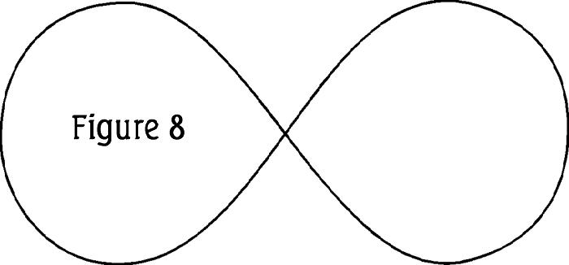
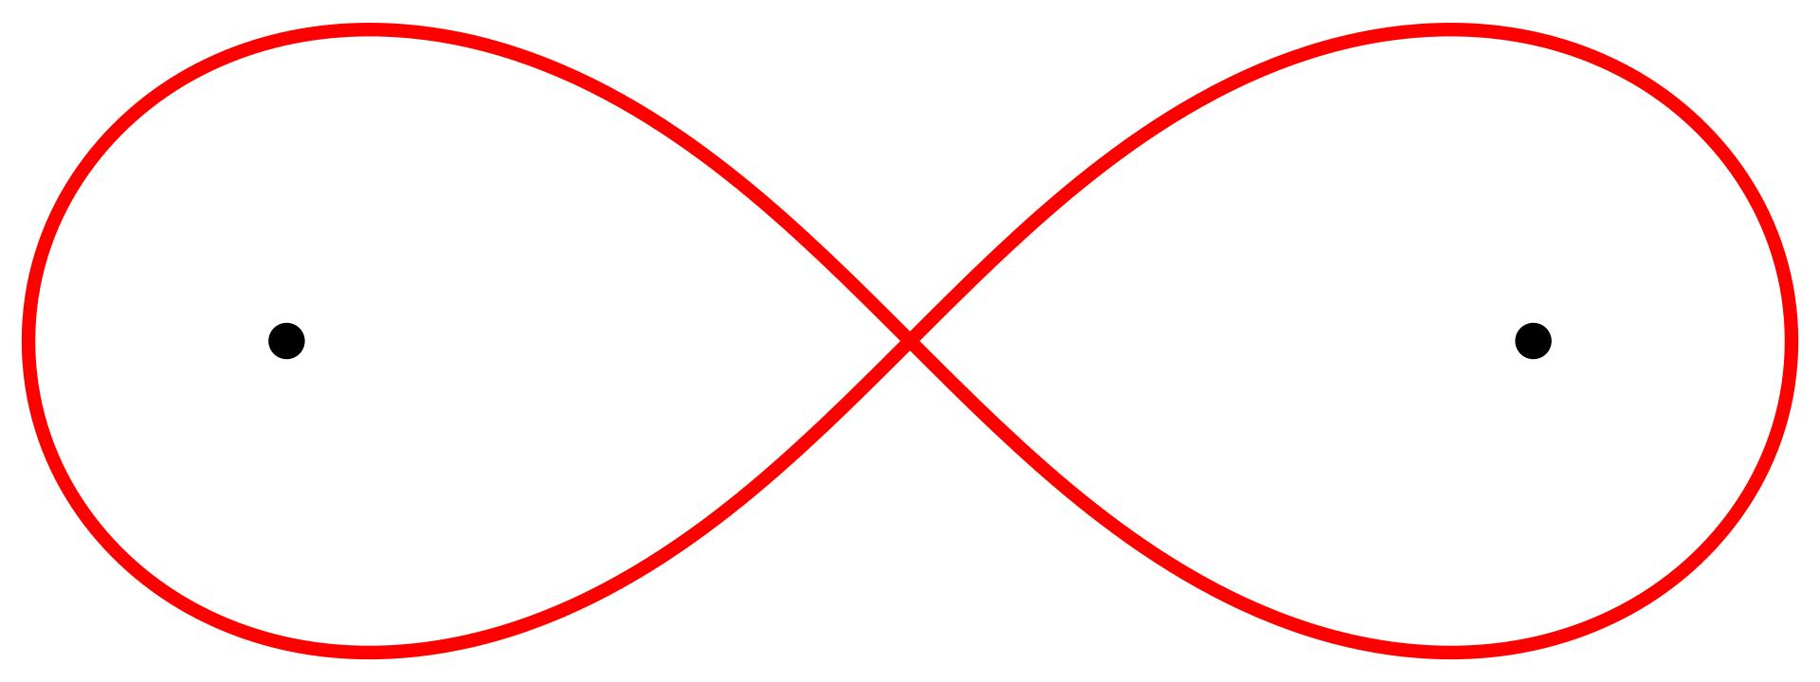
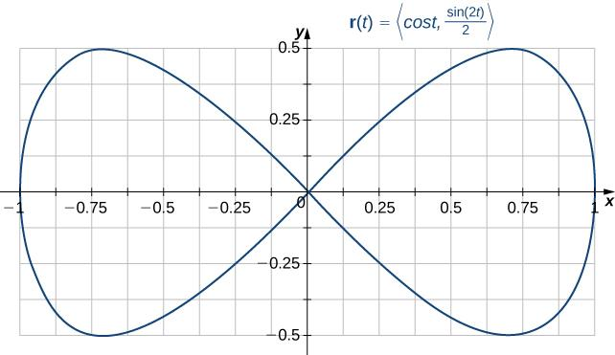
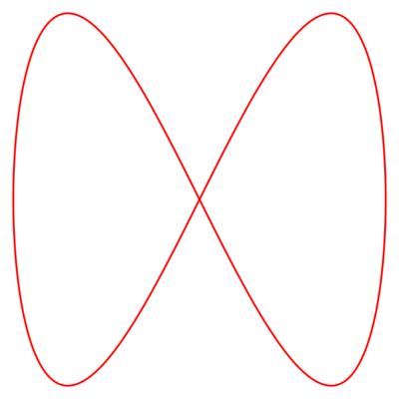
Example
A figure-eight loop is a common example.
The starting point eventually returns to itself, while the two loops intersect at another point.

12. Self-Intersecting Smooth Path
# Source: AI Source: Provided by: [Data Path: Persons Table -> ID Column: 1, Name_En Column: Motasem Essam] -> From: [ChatGPT] on [7/25/2026]
A Self-Intersecting Smooth Path crosses itself while remaining smooth at the crossing.
Example
A smooth figure-eight curve can have two different tangent directions at the intersection point.
The curve itself can remain differentiable even though it is not simple.

13. Self-Intersecting Non-Smooth Path
# Source: AI Source: Provided by: [Data Path: Persons Table -> ID Column: 1, Name_En Column: Motasem Essam] -> From: [ChatGPT] on [7/25/2026]
A Self-Intersecting Non-Smooth Path contains self-intersections and also has one or more corners or non-differentiable points.
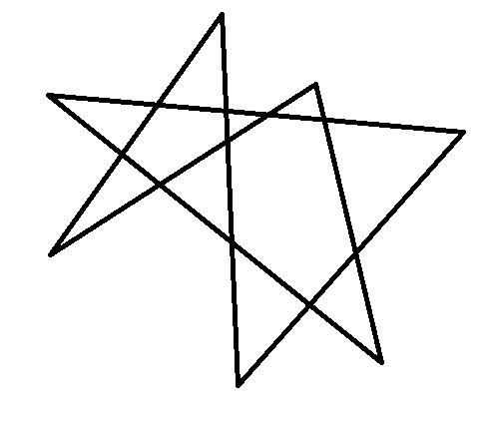
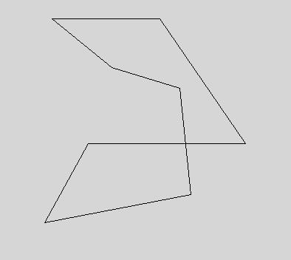
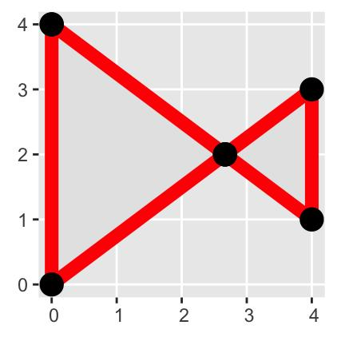
Example
A crossing polygonal chain can have:
- a self-intersection, and
- sharp vertices.
Therefore:
$$\boxed{\text{Self-Intersecting}⇏\text{Smooth}}$$

14. Self-Intersecting Convex-Like Path
# Source: AI Source: Provided by: [Data Path: Persons Table -> ID Column: 1, Name_En Column: Motasem Essam] -> From: [ChatGPT] on [7/25/2026]
Strictly speaking, a self-intersecting closed path does not bound a convex region in the ordinary sense.
Therefore, “convex-like” is descriptive rather than a standard mathematical classification.
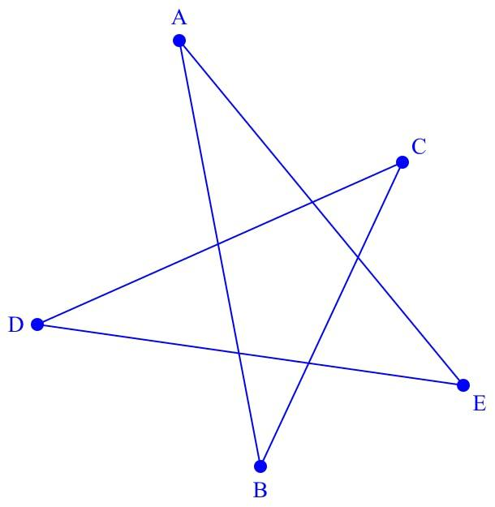
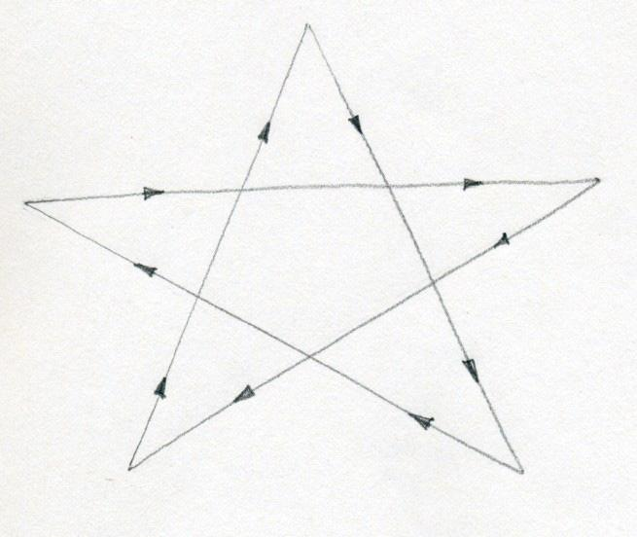
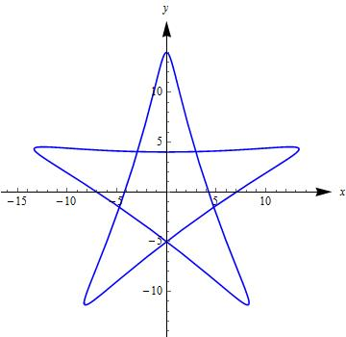
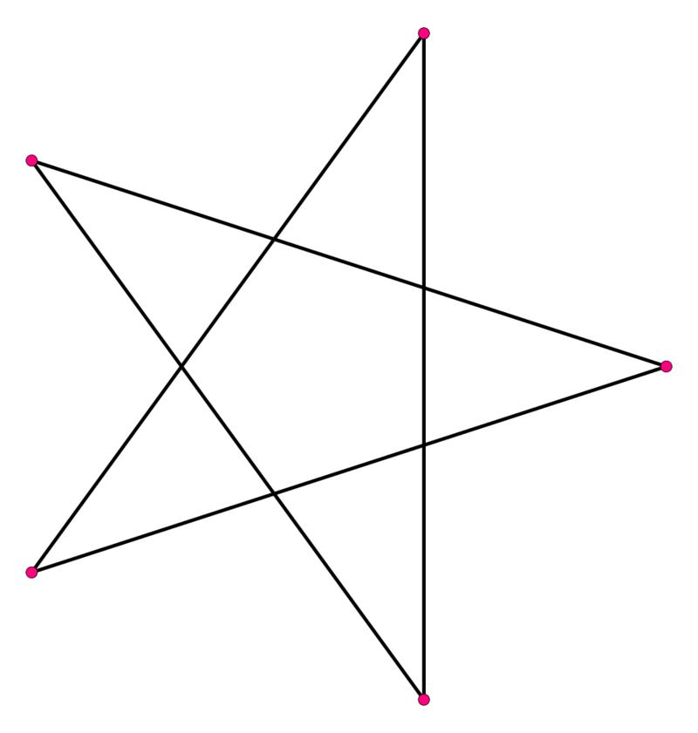
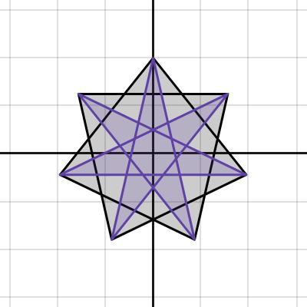
A star-shaped or crossing path may contain locally convex-looking portions, but the entire self-intersecting path is not a convex boundary.

15. Self-Intersecting Spiral Path
# Source: AI Source: Provided by: [Data Path: Persons Table -> ID Column: 1, Name_En Column: Motasem Essam] -> From: [ChatGPT] on [7/25/2026]
A Self-Intersecting Spiral Path is a spiral-like path that crosses an earlier portion of itself.
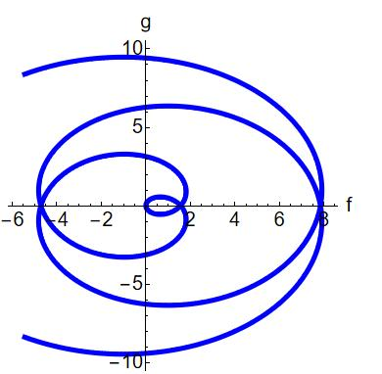
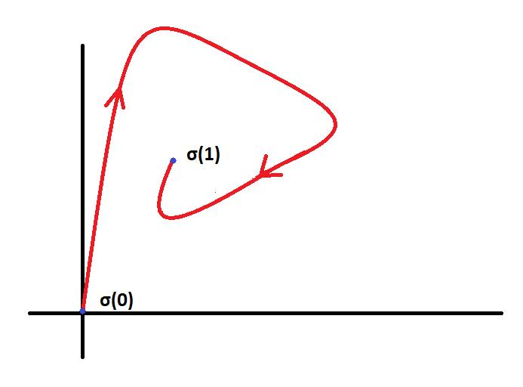
This can occur when the radial and angular behavior causes the curve to return to an earlier location.

16. Self-Intersecting Arc-Based Path
# Source: AI Source: Provided by: [Data Path: Persons Table -> ID Column: 1, Name_En Column: Motasem Essam] -> From: [ChatGPT] on [7/25/2026]
A Self-Intersecting Arc-Based Path is composed of arcs where one or more arcs intersect another part of the path.
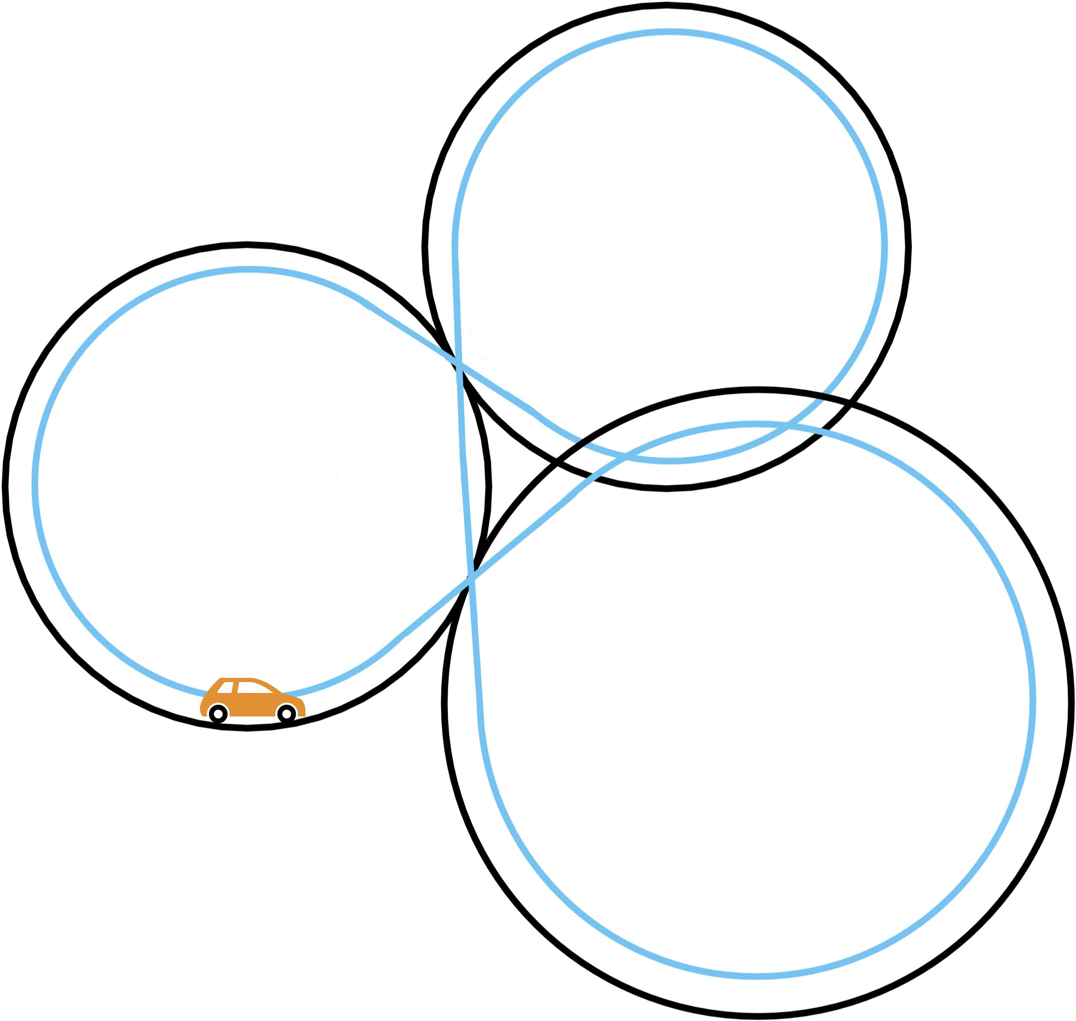
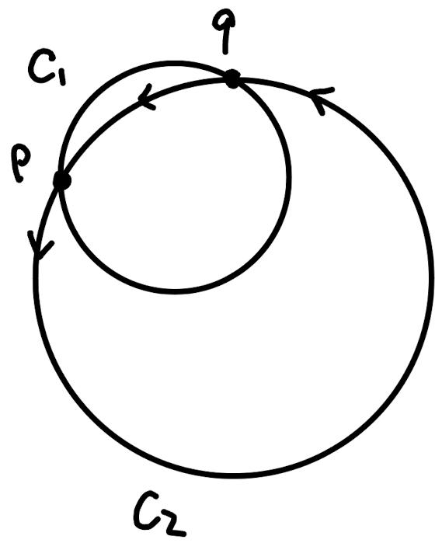
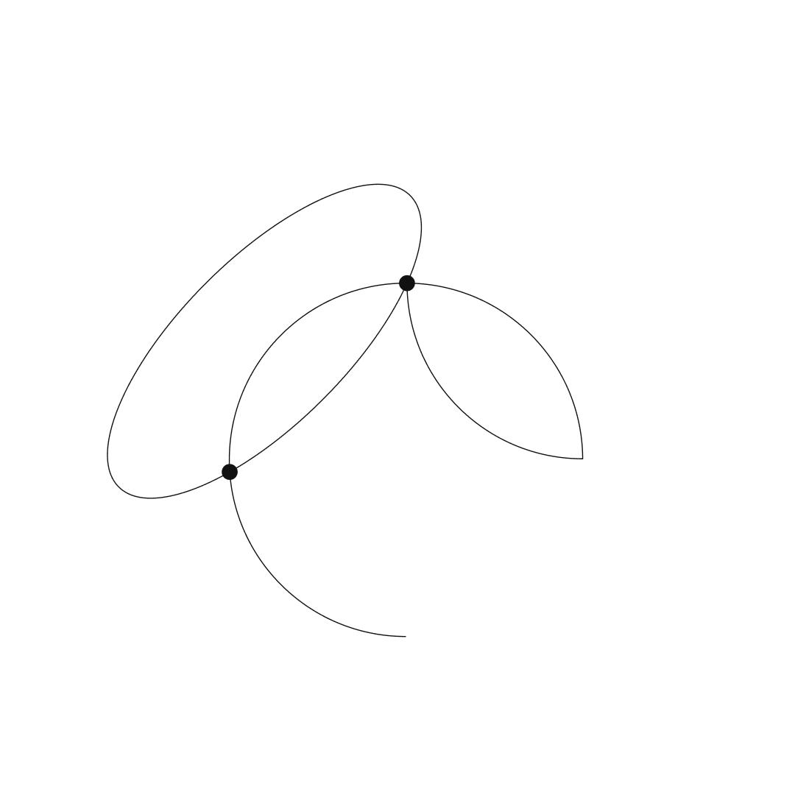
Example
If:
$$A_{1}∩A_{2}=\left\{P\right\}$$
and $A_{1},A_{2}$are nonconsecutive path pieces, the combined path is self-intersecting.

17. Self-Intersecting Restricted Path
# Source: AI Source: Provided by: [Data Path: Persons Table -> ID Column: 1, Name_En Column: Motasem Essam] -> From: [ChatGPT] on [7/25/2026]
A Self-Intersecting Restricted Path is a path that remains self-intersecting after applying a domain, parameter, or spatial restriction.
Example
A parameterized figure-eight curve may be restricted to:
$$0≤t≤4π$$
and still contain one or more self-intersections.

18. Multiple-Self-Intersection Path
# Source: AI Source: Provided by: [Data Path: Persons Table -> ID Column: 1, Name_En Column: Motasem Essam] -> From: [ChatGPT] on [7/25/2026]
A Multiple-Self-Intersection Path has more than one self-intersection.
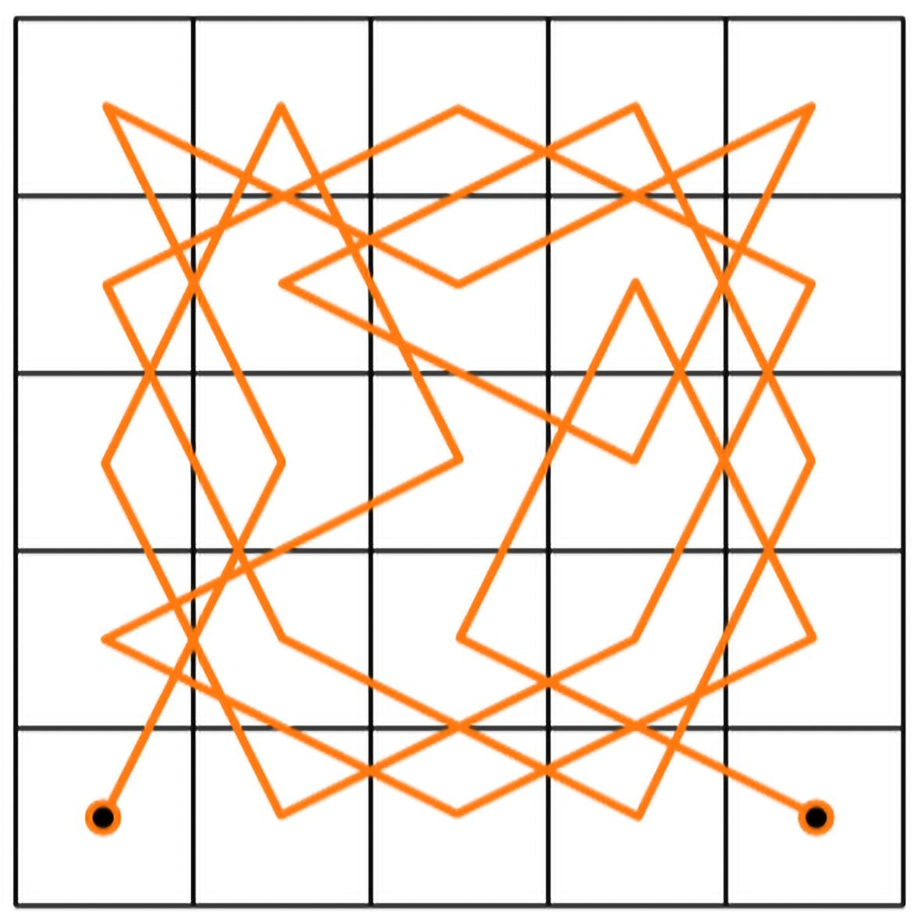
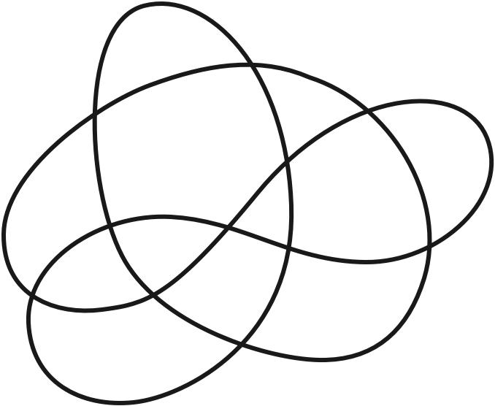
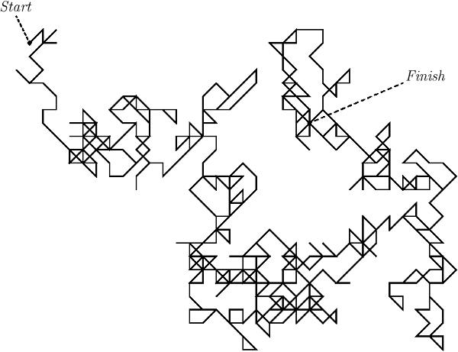
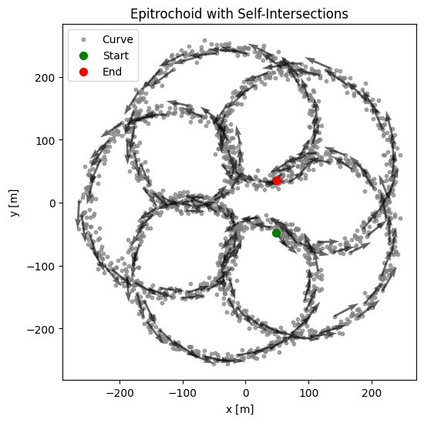
If the path contains intersection points
$$P_{1},P_{2},…,P_{k}$$
where:
$$k>1,$$
then it has multiple self-intersections.
Example
A complex crossing path may intersect itself at:
$$P_{1}, P_{2}, P_{3}.$$

19. Transversely Self-Intersecting Path
# Source: AI Source: Provided by: [Data Path: Persons Table -> ID Column: 1, Name_En Column: Motasem Essam] -> From: [ChatGPT] on [7/25/2026]
A Transversely Self-Intersecting Path crosses itself with different tangent directions at the intersection.
At intersection $P$:
$$\boxed{T_{1}\left(P\right)∦T_{2}\left(P\right)}$$
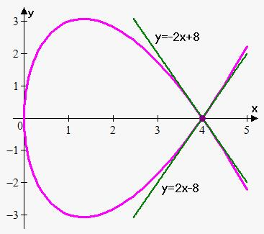
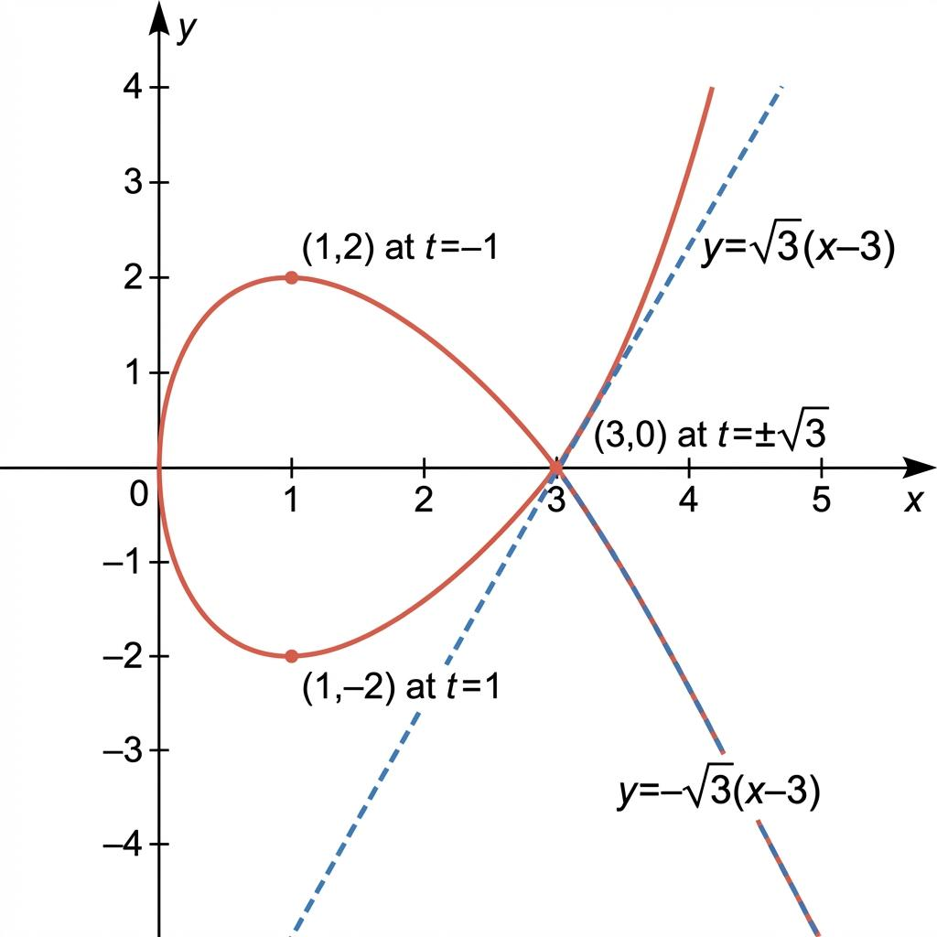
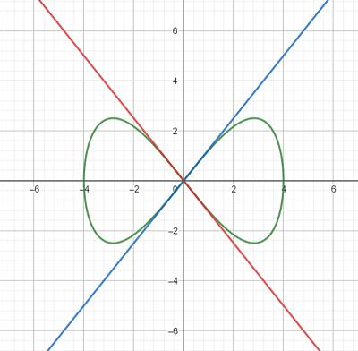
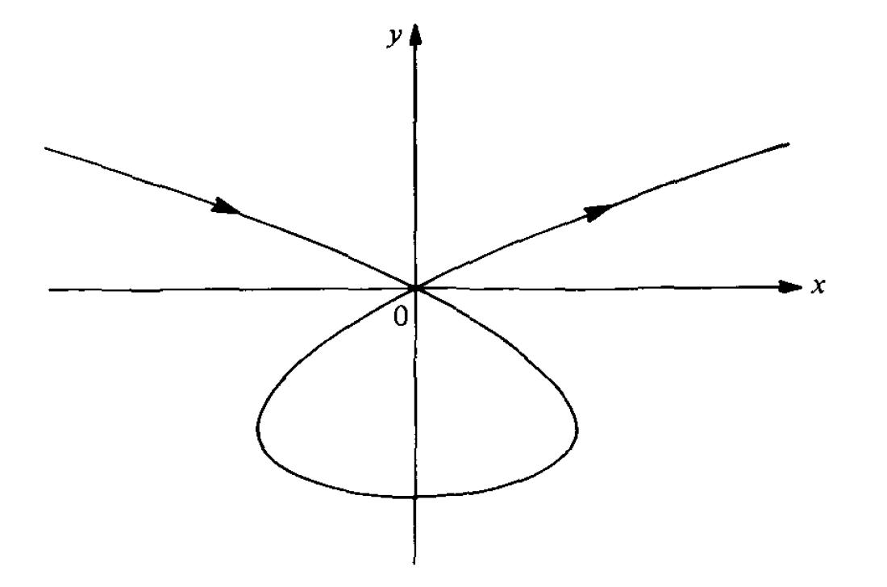
Example
A figure-eight curve crossing at its center is typically a transverse self-intersection.
The two branches pass through one another rather than merely touching.

20. Tangentially Self-Intersecting Path
# Source: AI Source: Provided by: [Data Path: Persons Table -> ID Column: 1, Name_En Column: Motasem Essam] -> From: [ChatGPT] on [7/25/2026]
A Tangentially Self-Intersecting Path returns to an earlier point while the two branches have the same tangent direction at that point.
$$\boxed{T_{1}\left(P\right)∥T_{2}\left(P\right)}$$
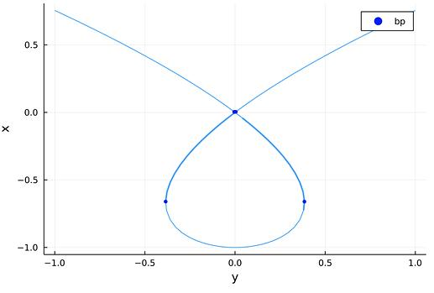
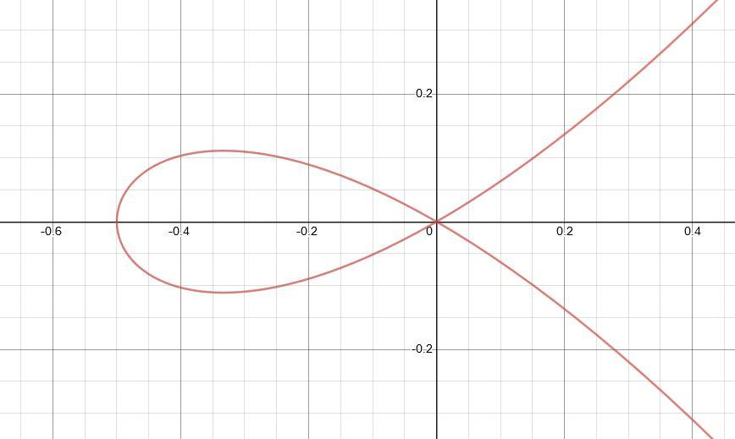
This is different from a transverse crossing because the branches touch with matching tangent direction rather than crossing with different directions.

Mathematical Test for Self-Intersection
# Source: AI Source: Provided by: [Data Path: Persons Table -> ID Column: 1, Name_En Column: Motasem Essam] -> From: [ChatGPT] on [7/25/2026]
For:
$$r\left(t\right)=\left\langle x , \left(t\right)y\left(t\right)\right\rangle$$
a self-intersection occurs if there exist:
$$t_{1}≠t_{2}$$
such that:
$$\boxed{x\left(t_{1}\right)=x\left(t_{2}\right)}$$
and:
$$\boxed{y\left(t_{1}\right)=y\left(t_{2}\right)}$$
together.
Therefore:
$$\boxed{r\left(t_{1}\right)=r\left(t_{2}\right), t_{1}≠t_{2}}$$
is the fundamental mathematical condition.

Self-Intersection in a Polygonal Path
# Source: AI Source: Provided by: [Data Path: Persons Table -> ID Column: 1, Name_En Column: Motasem Essam] -> From: [ChatGPT] on [7/25/2026]
For a polygonal path, self-intersection usually occurs when two nonconsecutive segments intersect.
For example:
$$\overset{‾}{P_{i}P_{i+1}}∩\overset{‾}{P_{j}P_{j+1}}≠∅$$
where the segments are nonconsecutive.
Example
If:
$$\overset{‾}{AB}∩\overset{‾}{CD}=\left\{P\right\}$$
then:
$$\boxed{\text{Path is self-intersecting}}$$
provided $AB$and $CD$are nonconsecutive pieces.

Self-Intersection vs Consecutive Connection
# Source: AI Source: Provided by: [Data Path: Persons Table -> ID Column: 1, Name_En Column: Motasem Essam] -> From: [ChatGPT] on [7/25/2026]
An important distinction is that consecutive path pieces are supposed to meet.
For:
$$A→B→C$$
the segments $AB$and $BC$meet at $B$.
That is not normally considered a self-intersection.
The problematic case is an intersection involving nonconsecutive pieces.
$$\boxed{\text{Consecutive connection}≠\text{Self-intersection}}$$

Simple Path vs Self-Intersecting Path
# Source: AI Source: Provided by: [Data Path: Persons Table -> ID Column: 1, Name_En Column: Motasem Essam] -> From: [ChatGPT] on [7/25/2026]
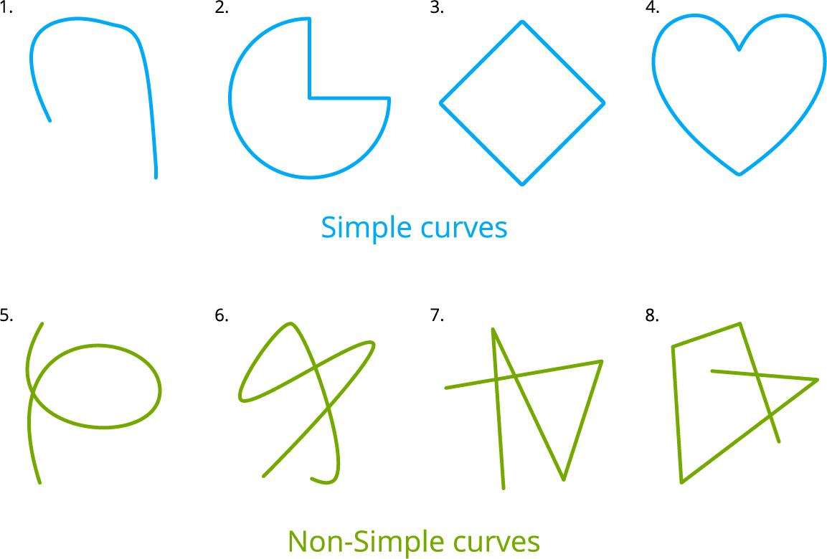
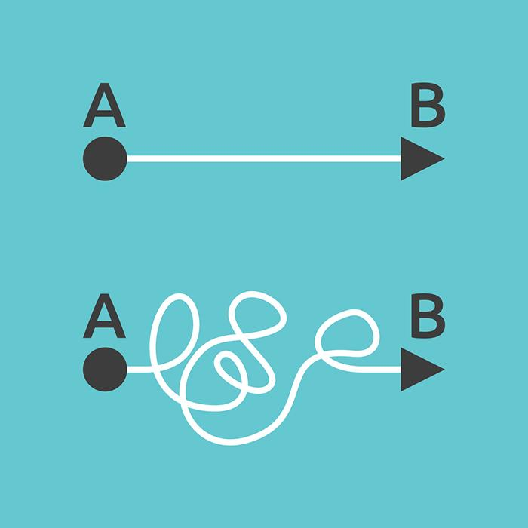
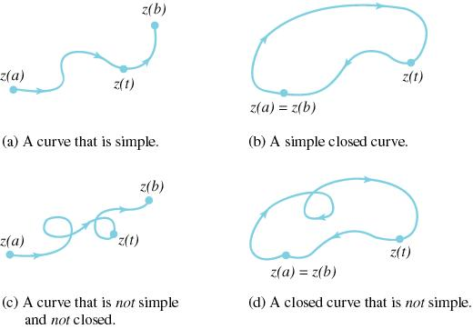
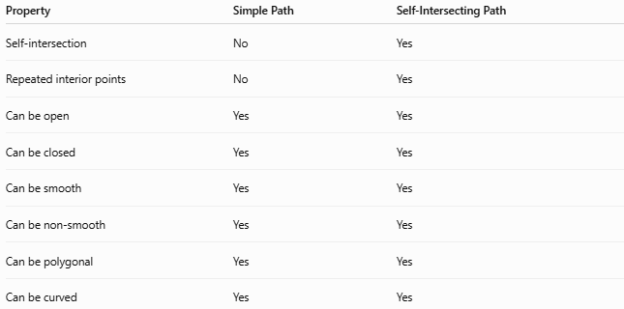
Property | Simple Path | Self-Intersecting Path
Self-intersection | No | Yes
Repeated interior points | No | Yes
Can be open | Yes | Yes
Can be closed | Yes | Yes
Can be smooth | Yes | Yes
Can be non-smooth | Yes | Yes
Can be polygonal | Yes | Yes
Can be curved | Yes | Yes
The fundamental distinction is:
$$\boxed{\text{Simple Path}=\text{No Self-Intersection}} \\ \boxed{\text{Self-Intersecting Path}=\text{At Least One Self-Intersection}}$$

Self-Intersecting Path vs Closed Path
# Source: AI Source: Provided by: [Data Path: Persons Table -> ID Column: 1, Name_En Column: Motasem Essam] -> From: [ChatGPT] on [7/25/2026]
These are not opposites.
A path can be:
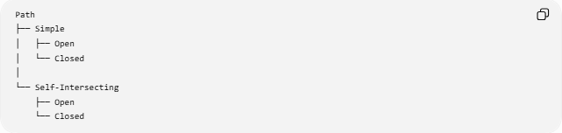
Path
├── Simple
│ ├── Open
│ └── Closed
│
└── Self-Intersecting
├── Open
└── Closed
Therefore:
$$\boxed{\text{Self-Intersecting Closed Path}}$$
is completely valid.

Self-Intersecting Path vs Complex Path
# Source: AI Source: Provided by: [Data Path: Persons Table -> ID Column: 1, Name_En Column: Motasem Essam] -> From: [ChatGPT] on [7/25/2026]
The terms are related but should not automatically be treated as identical.
Self-intersecting specifically means that a path intersects itself.
Complex is broader and may describe a path with complicated structure, multiple loops, multiple pieces, or other complexity.
Therefore:
$$\boxed{\text{Self-Intersecting}⇒\text{Has a Self-Crossing}}$$
but:
$$\boxed{\text{Complex}⇏\text{Self-Intersecting}}$$
unless the classification specifically defines it that way.

Classification Summary
# Source: AI Source: Provided by: [Data Path: Persons Table -> ID Column: 1, Name_En Column: Motasem Essam] -> From: [ChatGPT] on [7/25/2026]
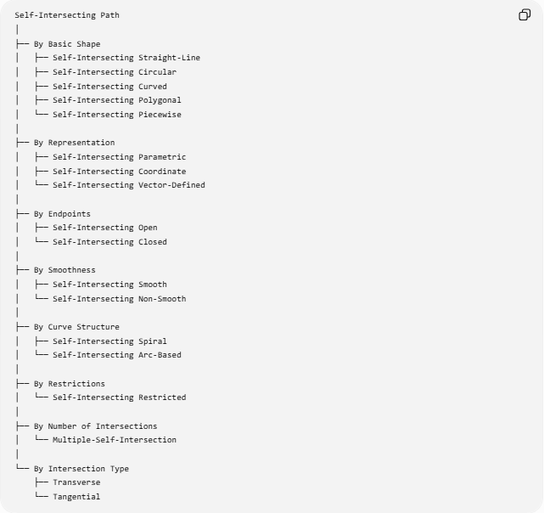
Self-Intersecting Path
│
├── By Basic Shape
│ ├── Self-Intersecting Straight-Line
│ ├── Self-Intersecting Circular
│ ├── Self-Intersecting Curved
│ ├── Self-Intersecting Polygonal
│ └── Self-Intersecting Piecewise
│
├── By Representation
│ ├── Self-Intersecting Parametric
│ ├── Self-Intersecting Coordinate
│ └── Self-Intersecting Vector-Defined
│
├── By Endpoints
│ ├── Self-Intersecting Open
│ └── Self-Intersecting Closed
│
├── By Smoothness
│ ├── Self-Intersecting Smooth
│ └── Self-Intersecting Non-Smooth
│
├── By Curve Structure
│ ├── Self-Intersecting Spiral
│ └── Self-Intersecting Arc-Based
│
├── By Restrictions
│ └── Self-Intersecting Restricted
│
├── By Number of Intersections
│ └── Multiple-Self-Intersection
│
└── By Intersection Type
├── Transverse
└── Tangential

Key Formulas
# Source: AI Source: Provided by: [Data Path: Persons Table -> ID Column: 1, Name_En Column: Motasem Essam] -> From: [ChatGPT] on [7/25/2026]
Fundamental Condition
$$\boxed{r\left(t_{1}\right)=r\left(t_{2}\right), t_{1}≠t_{2}}$$
Coordinate Form
$$\boxed{x\left(t_{1}\right)=x\left(t_{2}\right)} \\ \boxed{y\left(t_{1}\right)=y\left(t_{2}\right)}$$
Open Self-Intersecting Path
$$\boxed{P_{s}≠P_{e}}$$
plus at least one additional repeated point.
Closed Self-Intersecting Path
$$\boxed{P_{s}=P_{e}}$$
plus at least one additional self-intersection.
Polygonal Self-Intersection
$$\boxed{\overset{‾}{P_{i}P_{i+1}}∩\overset{‾}{P_{j}P_{j+1}}≠∅}$$
for nonconsecutive segments.

Key Points
# Source: AI Source: Provided by: [Data Path: Persons Table -> ID Column: 1, Name_En Column: Motasem Essam] -> From: [ChatGPT] on [7/25/2026]
- A Self-Intersecting Path intersects itself at one or more points.
- Its fundamental condition is:
$$\boxed{r\left(t_{1}\right)=r\left(t_{2}\right), t_{1}≠t_{2}}$$
- A self-intersection is different from the normal connection between consecutive path pieces.
- A self-intersecting path can be open or closed.
- It can be smooth or non-smooth.
- It can be polygonal, curved, piecewise, or parametric.
- A figure-eight is a common example.
- Multiple self-intersections are possible.
- Self-intersections can be transverse or tangential.
- A self-intersecting closed path does not form a simple polygonal boundary.
- Simple Path and Self-Intersecting Path are complementary classifications with respect to self-intersection.

Conclusion
# Source: AI Source: Provided by: [Data Path: Persons Table -> ID Column: 1, Name_En Column: Motasem Essam] -> From: [ChatGPT] on [7/25/2026]
A Self-Intersecting Path is a geometric path that returns to a point it has previously visited, creating one or more self-intersections.
Its fundamental mathematical condition is:
$$\boxed{∃ t_{1}≠t_{2}\text{ such that }r\left(t_{1}\right)=r\left(t_{2}\right)}$$
except for the permitted start/end coincidence of a closed path.
Self-intersection is independent of whether a path is open or closed, straight-piece or curved, smooth or non-smooth, polygonal or parametric.
The essential distinction is:
$$\boxed{\text{Simple Path }⟺\text{ No Self-Intersection}}$$
whereas:
$$\boxed{\text{Self-Intersecting Path }⟺\text{ At Least One Self-Intersection}}$$

